TITLE OF PAPER (style heading 1: font formats - times new roman, 12 pt bold, ALL CAPS; paragraph formats: centered, spacing before 0 pt, spacing after 0 pt, keep with next, KEEP LINES TOGETHER)
UDC (12pt italic, centered, spacing before 6 pt, spacing after 10 pt,
keep with next)

Authors
(Style Heading 2: 10 pt bold, title case, centered, spacing before 0 pt, spacing after 12 pt, keep with next, keep lines together)
Affiliation (Style Affiliation: 10 pt, centered, spacing before 0 pt, after 18 pt, keep with next)
Abstract (bold). Abstract up to 300 words (Style Abstract: 9 pt, italic, justified, 0.75 cm left and right indentation).
Key words (bold): key word 1, key word 2... to (max) key word 5
JEL Classification (bold): (9pt, separated by commas, justified, 0.75 cm left and right indentation, spacing before 18 pt, after 0 pt, keep with next). Please indicate appropriate JEL classification codes (https://www.aeaweb.org/econlit/jelCodes.php)

1. Main heading (Style Heading 3: small caps 10 pt, centered, spacing before 24 pt, spacing after 6 pt, keep with next, keep lines together)
Main text: only use characters and symbols available in the Times New Roman or Symbol font (as in the full text of paper), 10 pt; paragraph format: justified alignment, left and right indent 0 pt, space before and after 0 pt, first line indent 0.5 cm.

1.1. Subheading (Style Heading 4: 10 pt, bold, left, indentation left 5 pt,
spacing before 12 pt, after 6 pt, keep with next, keep lines together)
Sample of main text. Sample of main text. Sample of main text. Sample of main text. Sample of main text. Sample of main text. Sample of main text. Sample of main text. Sample of main text. Sample of main text. Sample of main text. Sample of main text. Sample of main text. Sample of main text. Sample of main text. Sample of main text. Sample of main text. Sample of main text. Sample of main text. Sample of main text. Sample of main text. Sample of main text. Sample of main text. Sample of main text.

1.1.1. Subheading of the 3nd level (Style Heading 5: 10 pt, italic, left, indentation left 5 pt, spacing before 12 pt, after 6pt, keep with next, keep lines together)
Sample of main text. Sample of main text. Sample of main text. Sample of main text. Sample of main text. Sample of main text. Sample of main text. Sample of main text. Sample of main text. Sample of main text. Sample of main text. Sample of main text.
Equations
Equations (refer with: Eq. 1, Eq. 2,...) should be placed in the middle, denoted by numbers in round parentheses and transformed by equation conversion manager, do not use Print Screen or jpg format. For example:
(1)

Illustrations: figures, photographs, line drawings, graphs
(Styles Figure and Figure Title)

Fig. 2 Title of figure
Source: xxxxxx
All illustrations (figures, photographs, line drawings, graphs) should be numbered in series with consecutive Arabic numbers and all legends should be included at the bottom of each illustration. All figures, photographs, line drawings and graphs, prepared in electronic form, should be converted in TIFF or JPG (max quality) files, in 300 dpi resolution, for superior reproduction. Figures, line drawings and graphs prepared using elements of MS Drawing or MS Graph must be converted in form of pictures and unchangeable. All illustrations should be planned in advance so as to allow reduction to 12.75 cm in column width. Please review all illustrations to ensure that they are readable.

Tables and figures should be numbered and references to them must be in the text. Acceptable labeling for a table is Tab.1 and Fig. 1 for a figure.
Table 1: Table description (TNR 10pt., italics)
Times New Roman 10pt | Times New Roman 10pt | Times New Roman 10pt
Times New Roman 10pt | Times New Roman 10pt | Times New Roman 10pt
Times New Roman 10pt | Times New Roman 10pt | Times New Roman 10pt
Times New Roman 10pt | Times New Roman 10pt | Times New Roman 10pt

Source: (TNR 10pt., italics)
Acknowledgement: The paper is a part of the research done within the project 1234567890. The authors would like to thank to the... (Style Acknowledgement).
Citation in the text
The APA style citation and referencing is applied in the journal (according to the instructions that can be downloaded from the link http://www.apastyle.org).
Citations in the text should be given in brackets, stating the author's surname, year of publication and, possibly, pages, if it is a direct quote):
- in the case of summary or paraphrase, references should appear in brackets with the author's name, followed by the year (Miles, 2015), or (Enukidze & Weis, 2001) or in the case of multiple authors (Pimonenko et al., 2007);
- if the author is not known, give the title of the work and the year (Migration trends, 2009);
- if the same author has published more than two papers at the same year, then the papers are alphabetically separated, i.e. (Vasic, 1990a; 1990b);
- in the case of quotation, add the page number, i.e. (Gilles, 2001, p. 10);
- if the reference is within the body of the clause, give the author’s name and only the year of the paper in brackets, i.e. In Gilles (2001) it is proposed …

References
References should follow the APA Style convention, in alphabetical order at the end of the paper. If a referenced paper has multiple authors, they all should be quoted.

The list of references should be formatted so that the second row in each entry is indented (Paragraph Indentation, Special - choose Hanging, by 0.5cm).

Wherever possible, provide the DOI number, too, in addition to other reference data.

Please, check the examples:

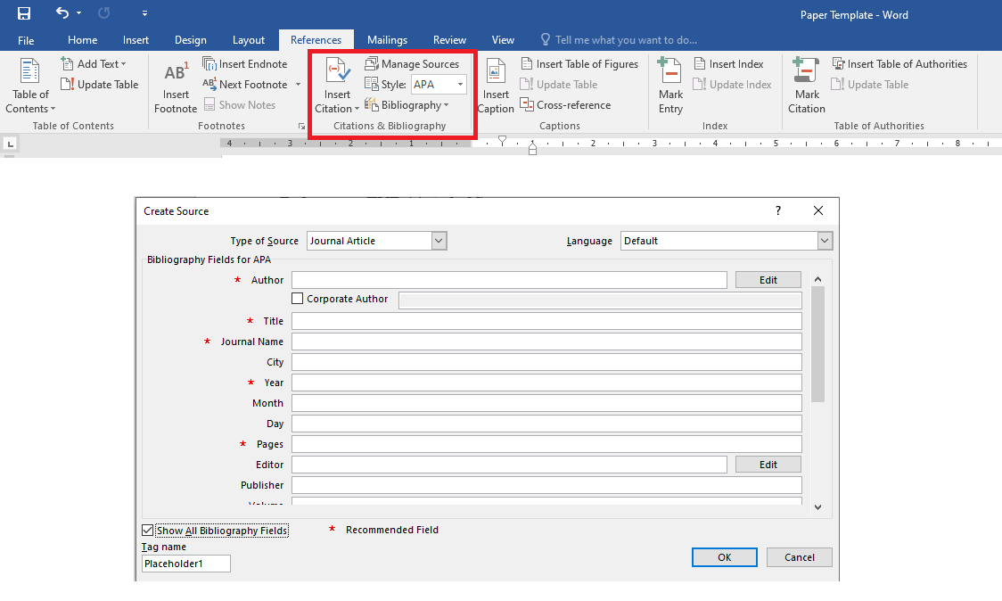

(Book style - Author, year. Title (in italics). Publisher, location of publisher.)
Weis, L. and Vasic, M., (2021). New Ways of Networking, 1st ed. Chichester, U.K.: Wiley.
Layarevski, P. (2019). Managing Systems, Belmont, CA: Wadsworth, pp. 183-223.
(Journal - Author, year. Paper title. Journal name (in italics), volume and issue numbers, inclusive pages.)
Nice, E., Miller, B. and Few, G. L. (2020). “A new technique for developing digital communications,” EUMMAS Business Review, vol. 9, pp. 120-157.
Willes, R. M. (2021). Nonlinear modeling of social and economic patterns. Economics and Sociology, European Journal of Operational Management Practice and Research, vol. 23, pp. 287-322.
(Online Sources style)
Hample, D. J. (September 2012). Shadow economy and economic development. EUMMAS Review [Online]. 11(6). pp. 25-86. Available: http://www.eummas.info/hub/33ps02-hample
(Conference paper or contributed volume - Author, year, paper title. Proceedings title (in italics). City, country, inclusive pages.)
Miele, V. and Johnes, F. (2019). New Big 5s. Proceedings of EUMMAS Conference of Strategic Management. Milano, Italy, pp. 229-165.

